

Getting Started with Neo4j: A Beginner’s Tutorial Using Docker

Project Report

submitted in

Partial Fulfillment of the Requirements

for

MSDS 555: Big Data Management and Analytics

by

Isaac Adebayo

Farhana Manzoor

Michella Maddox-McGhee



DEPARTMENT OF COMPUTER SCIENCE AND DATA SCIENCE:

SCHOOL OF APPLIED COMPUTATIONAL SCIENCES

MEHARRY MEDICAL COLLEGE

1005 DR. DB TODD JR BLVD. NASHVILLE, TN 37208

Submission Date: August 12, 2025
Executive Summary
Neo4j is a special kind of database that stores information like a map. Instead of keeping data in boxes and rows like a spreadsheet, it connects pieces of information together, kind of like how dots are connected by lines in a drawing. Each “dot” is called a node and each “line” is called a relationship. This makes it really easy to see how nodes are linked.

Because Neo4j is built to understand connections, it can find answers very quickly, even if there are millions of dots and lines. It uses a tool called Cypher to ask questions about the data, and the answers can help solve real problems. For example, it can help find friends you might know on social media, stop bad guys from stealing money, or suggest movies you might like.

People use Neo4j in many ways, like making knowledge maps for AI, spotting fraud in banks, giving recommendations in online stores, and keeping big company records organized. It’s like having a smart map that not only shows you where everything is, but also helps you discover new paths you didn’t see before.

TABLE OF CONTENTS

- Executive Summary ........................................................... 1
- Part 1: Introduction ........................................................... 3
- Part 2: Objectives .............................................................. 3
- Part 3: Exploring Neo4j–The Native Graph Database ...... 4
3.1 Nodes ................................................................... 4
3.2 Relationships ........................................................ 5
3.3 Properties ............................................................. 6
3.4 Table: Neo4j Graph Data Model Elements ........ 6,7
3.5 Key Advantages of Graph Databases .................. 8
3.6 Core Functionalities and the Cypher Query
Language ……………………………………………………………....8
3.7 Key Clauses: MATCH, WHERE, RETURN ............... 9
3.8 Data Manipulation: CREATE, MERGE, DELETE,
SET, REMOVE…………………………………………………………..9
3.9 Key Advantages and Benefits ............................. 10
3.10 Real-World Applications and Use Cases ........... 11
- Part 4: Docker ................................................................... 11
- Part 5: System Design and Architecture ........................... 11
5.1 Graph Model ...................................................... 12
- Part 6: Demo .................................................................... 13
Step 1: Run Neo4j in Docker ..................................... 13
Step 2: Open Neo4j in Your Browser ........................ 14
Step 3: Create the Family Graph .............................. 14
Step 4: Query the Graph .......................................... 15
- Part 7: Real-World Impact ............................................... 16
- Part 8: Group Activity and Contribution .......................... 16
- Part 9: Conclusion ........................................................ 17

Part 1. Introduction
To understand Neo4j, imagine your data as a big web where everything connects, like friends with each other, posts that share comments, or cities linked by roads. Neo4j is a kind of database designed especially for that kind of connected data. It doesn’t store information in boring grids or tables; it stores it as dots (nodes) and lines (relationships), which makes it feel more like a picture you can explore.

Think of each piece of information (like a person, place, or thing) as a node, a labeled dot. The connections between them (like friendships, purchases, or directions) are called relationships. Are you ready for the neat part? Both nodes and lines can each have little notes or details attached to them (like names, dates, or labels). So you can keep extra info right where it belongs.

Traditional databases often treat connections like afterthoughts. Neo4j treats them like VIPs. It’s built from the ground up to work with linked data. That means when you want to follow a path through your data—like finding who’s connected to whom—it’s super fast and smooth.

Instead of writing complicated codes, Neo4j uses an easy-to-read language called Cypher. It looks a bit like English and also draws pictures with parentheses and arrows. For instance, you might write something like (Alice)-[:KNOWS]->(Bob) to say “Alice knows Bob.” It feels like a drawing, but it’s actually just asking the database to find that connection for you.

Because Neo4j handles relationships so naturally, it’s used in clever ways such as:

- Building knowledge maps that help AI understand how things are connected.
- Spotting fraud by following unusual chains between users or transactions.
- Giving recommendations—like suggesting friends, movies, or products—based on how items and users are linked.
- Organizing big sets of data so everything stays consistent and easy to manage.

By the end of this tutorial, you'll not only understand what Neo4j is, but also why it's so friendly for solving real problems involving connected information. It’s like having a smart, interactive map of your data where every path leads to a discovery.

Part 2. Objectives

- Offer a practical, hands-on guide to using Neo4j.

- Lay out the foundational ideas and architectural structure behind the technology.

- Highlight real-world scenarios where Neo4j delivers clear benefits.

- Walk the reader through a thorough, step-by-step understanding of Neo4j.

- Begin with deep, standalone explorations of each key aspect before moving into how they connect and work together.

Part 3. Exploring Neo4j: The Native Graph Database

Neo4j is a native graph database that follows the ACID properties, making it reliable for storing and querying highly connected data.

3.1 Nodes

The data model in a graph database consists of nodes, relationships, and properties.
Nodes represent entities like people, cities, books, or accounts. Relationships connect exactly two nodes and can be typed and directed. They can also have properties. Properties add relevant context to nodes and relationships

Cypher is Neo4j's native query language. It works using a declarative, pattern-matching approach tailored for the graph model. You describe a pattern, and Cypher finds and returns the matching data.

In graph theory, nodes are also called vertices and are linked using edges.
A node can represent an entity such as a person, city, account, or book. A node can also have attributes, known as properties, like a name or age. Nodes are useful for analyzing connections, which reveal patterns and structures.

Neo4j is an example of a graph database where nodes are first-class citizens.
They store labels (types) and properties (key-value pairs). Nodes are connected through relationships, which can also have properties.

Example of a Node:
// A single node with one label and a few properties
CREATE (:Person {name: 'Isaac Adebayo', born: 1815});

// Multiple labels (type + role)
CREATE (:Person:Engineer {name: 'Brian Hopper', born: 1906});

// Example from football context
CREATE (:Player {name: 'Lionel Messi', rank: 1, goals: 106, country: 'Argentina'});

Example of Labels
Labels are used to classify nodes.
A node can have multiple labels.

// Add a label
MATCH (p:Person {name:'Ada Lovelace'})
SET p:Mathematician;

// Remove a label
MATCH (p:Person:Engineer {name:'Grace Hopper'})
REMOVE p:Engineer;

Example of Properties:
Properties are key-value pairs on nodes and relationships.
They can be numbers, strings, booleans, arrays, or temporal and spatial data.

CREATE (:City {name:'Winnipeg', population:749607, founded: date('1873-11-08')});
CREATE (:Book {title:'SQL Basics', isbn:'0-7925-6962-8', rating:4.8});

Nodes are connected via relationships, also known as edges.
In Neo4j, relationships are directed, typed, and property-bearing.

Example of How Nodes are Connected:
// Player -> Country
MATCH (p:Player {name:'Lionel Messi'})
MERGE (c:Country {name:'Argentina'})
MERGE (p)-[:PLAYS_FOR]->(c);

// Person -> City
MATCH (ada:Person {name:'Ada Lovelace'}), (london:City {name:'London'})
MERGE (ada)-[:LIVED_IN {from: date('1835-01-01')}]->(london);

// Book -> Person (authorship)
MATCH (b:Book {title:'SQL Basics'})
MERGE (a:Person {name:'Jane Doe'})
MERGE (a)-[:AUTHORED {year: 2020}]->(b);

3.2 Relationships

A relationship connects two nodes and can be directed or undirected.
In Neo4j, each relationship links two nodes together. It has a single type, a direction, and can store properties.

Examples of Relationships and How Entities are Associated.
MERGE (p:Person {name:'Isaac Lovelace'})
MERGE (c:Company {name:'Analytical Engines Ltd'})
MERGE (p)-[r:WORKS_AT {since:date('1835-01-01')}]->(c)

Types and Contextual Information:
The following design tips can be used to describe types and contextual information.

“Type” (can be regarded as name): Should be one per relationship and must be explicit.

Example:
WORKS_AT, PLAYS_FOR (Avoid words like RELATED_TO)

“Direction:” is used to match the domain flow.

Example:
(:Author)-[:AUTHORED]->(:Book) can be queried with -[:TYPE]- If the direction is not needed.

Properties should be used for context, such as dates, weights, or roles. Cardinality patterns may include 1-1, 1-many, or many-many.

Uniqueness & Duplicates:
Use MERGE to avoid duplicate edges.

3.3 Properties

In graph theory, properties are key-value pairs attached to nodes or relationships that store attributes describing them. Properties are not structural; they do not affect the graph's connections but add context about the entities and their relationships.

In Neo4j, nodes and relationships can have zero or multiple properties.
They are schema-optional and are physically stored within the node or relationship.

In traversal, Neo4j stores direct pointers from nodes to their relationships and vice versa.
This allows for constant-time traversal regardless of the graph size.

Pattern matching consists of Cypher queries that visually express patterns.
You can match labels using “(:Label)” or no label with “()”. Relationships can be matched with” –[]-” or with a specific one using “–[:TYPE]-”.

Unlike SQL databases, Neo4j does not store data in a relational table format.
It uses native graph storage. Nodes are stored in fixed-size records, which assign properties to their first relationship and property records.
Relationships are also stored in fixed-size records, assigning pointers to connected nodes and their properties, and linking other relationships from the same node. Finally, properties are stored in property records directly linked to nodes or relationships.

For performance, this native storage model supports relationship-intensive queries efficiently. The O(1) traversal allows constant-time access, eliminates the need for complex join operations, and uses indexes for faster query starts.

3.4 Table: Neo4j Graph Data Model Elements

Element | What It Is | Key Traits | Example (Cypher) | Notes / Best Practices
Node | An entity/thing | Holds properties; can have multiple labels | CREATE (:Person {name:'Ada', born:1815}) | Model real-world nouns (Person, City, Book). Avoid using internal IDs as business keys.
Label | A node’s type/tag | 0..N per node; used for indexing & semantics | MATCH (p:Person) · SET p:Engineer | Use singular, PascalCase (:Person). Keep labels stable; prefer properties for volatile states.
Relationship | A typed, directed link between two nodes | Can have properties; exactly two endpoints | MATCH (a:Person),(c:Company) CREATE (a)-[:WORKS_AT]->(c) | Direction is stored; you can match either direction with -[:TYPE]-.
Relationship Type | The name of a relationship | One type per relationship; ALL_CAPS | -[:FRIENDS_WITH]-> | Use specific verbs/nouns (:WORKS_AT, :AUTHORED). Don’t use overly generic :RELATED_TO.
Property | Key–value on nodes/relationships | Scalar/array, temporal, spatial supported | SET p.email='a@x.com' · SET r.since=date('2020-01-01') | Put context on the edge if it describes the connection (e.g., since, weight).
Path | An ordered sequence of nodes/relationships | Returned as a single object | MATCH p = (a)-[:FRIENDS_WITH*1..3]->(b) RETURN p | Great for shortest paths and traversals; inspect with nodes(p), relationships(p).
Pattern | A graph shape to match/create | ASCII-art syntax | MATCH (p:Person)-[:LIVES_IN]->(c:City) | Compose patterns; add predicates in WHERE. Use MERGE for idempotent upserts.
MERGE | Match-or-create (upsert) for patterns | Ensures no duplicates for the pattern | MERGE (b:Book {isbn:'0-7925'}) | Pair with unique constraints for true deduplication. Use ON CREATE/ON MATCH to set props.
Index (Node) | Speeds lookups by label+property | Used to find start nodes fast | CREATE INDEX IF NOT EXISTS FOR (p:Person) ON (p.name) | Index fields you filter on frequently (WHERE p.name=...).
Index (Relationship) | Speeds filtering by relationship props | Neo4j 5+ supports rel-property indexes | CREATE INDEX IF NOT EXISTS FOR ()-[r:WORKS_AT]-() ON (r.since) | Useful when queries filter on edge attributes.
Constraint: Uniqueness | Ensures property (or composite) is unique | Data integrity + MERGE support | CREATE CONSTRAINT IF NOT EXISTS FOR (b:Book) REQUIRE b.isbn IS UNIQUE | Use composite uniqueness for natural keys: (name,country).
Element IDs | Internal identifiers | Use elementId()(string) | RETURN elementId(n) | Don’t rely on internal IDs as business keys; store your own uuid/id.
Traversal | Pointer hops through the graph | O(1) per hop; index only for start | MATCH (a:Person {name:'Ada'})-[:FRIENDS_WITH*..2]-(x) | Performance scales with path length, not total graph size—ideal for relationship-heavy queries.
Native Storage | Node/rel records with direct pointers | Properties linked from records | (storage-level; no Cypher) | No joins: direct pointers enable fast graph walks and relationship-intensive analytics.

3.5 Key Advantages of Graph Databases: Speed, Flexibility, and Insight Generation

- Speed
Neo4j stores data in a way that allows fast access by using direct links between nodes and relationships, rather than relying on complex table structures that can slow things down. This makes it very quick to run even the most demanding queries, especially those involving many relationships.
- Flexibility
Neo4j allows you to add new types of data (like new labels) without changing the structure of your database. A single node can have multiple labels, which means it can be used in different ways depending on the context, making it very adaptable.
- Insightful Analysis
Using Cypher, you can easily describe complex relationships in your data, such as finding the shortest path or identifying communities. Edges (or connections between nodes) can have properties, which allow for more detailed analysis. Neo4j also allows you to use other graph analysis tools, making it easier to uncover hidden patterns in your data.
- Agility
Neo4j makes it easy to build and test new ideas quickly. You can create models directly in the database without having to go through time-consuming migration processes. Adding new data or relationships doesn't require restructuring the entire database, making it very efficient.

3.6 Core Functionalities and the Cypher Query Language

Cypher is the query language used in Neo4j to work with graph data. Its main purpose is to find patterns in your data, such as nodes, relationships, and paths. The goal of Cypher is to make it clear what you want, and then find the most efficient way to get that information.

To use Cypher, you create, read, update, and delete data, and then analyze the results for performance and data integrity.
Cypher identifies patterns by looking for specific combinations of nodes, relationships, and paths. This makes it easy to understand and work with your data. Cypher is popular because it's easy to read, efficient for traversing data, and helps you build models quickly.

When you run a Cypher query, the system first parses the pattern into a structure called a query tree. Then, it chooses the most efficient way to execute the query. The engine starts by finding the right nodes using indexes, then follows the relationships as described in your query. At each step, it applies filters to reduce the amount of data being processed before returning the final results.

Optimizations such as fast index lookups and early filtering help reduce the number of paths explored, making queries faster. The advantages of Cypher include a flexible schema, powerful path queries, built-in graph algorithms, concise syntax, and a way to express graph data naturally.

3.7 Key Clauses: MATCH, WHERE, RETURN

- MATCH
The purpose of `MATCH` is to describe a pattern of nodes and relationships you want to find. You can include multiple patterns in a single `MATCH` statement by separating them with commas.

- WHERE
The `WHERE` clause is used to filter the results. You can use it to compare values, check for text patterns, or use set operations like `IN` or `ANY`.

- RETURN
The `RETURN` clause is used to specify what data you want to get back. It can include properties, expressions, aggregations, and sorting or limiting results. Examples of what you can do with `RETURN` include projecting specific properties, renaming them, and performing calculations.

3.8 Data Manipulation: CREATE, MERGE, DELETE, SET, REMOVE

- CREATE
The purpose of `CREATE` is to add new nodes or relationships to your database. It always creates new data, even if it may already exist. It’s useful for inserting fresh nodes, relationships, and their properties.

- MERGE
The purpose of `MERGE` is to check if a pattern of nodes or relationships already exists. If it doesn't, it creates it. This helps avoid duplicates and ensures data is consistent.

- DELETE
The `DELETE` clause is used to remove nodes or relationships. To delete a node that has relationships, you need to first delete the relationships using `DETACH DELETE`.
- SET
The purpose of `SET` is to add or update properties and labels on nodes or relationships.
It can be used to create or overwrite property values or add new labels.

- REMOVE
The purpose of `REMOVE` is to delete properties or labels from a node or relationship.

3.9 Key Advantages and Benefits

Neo4j's design as a native graph database provides several distinct advantages that make it highly effective for handling connected data.

The following 5 advantages will be discussed below:

- Native Graph Storage & Processing
Neo4j stores nodes and relationships using direct physical pointers. It's ideal for data that involves a lot of relationships, such as social networks. It eliminates the need for costly join operations, as traversal is fast and efficient, regardless of how large the graph may be.

- Speed in Relationship Traversals
Traversals scale with path length, not the size of the dataset. Even with billions of connections, you can explore paths in milliseconds.

- Flexible, Schema-Optional Model
No rigid schema is required; labels, relationships, and properties can be added on the fly. Nodes can have multiple labels, allowing them to serve multiple roles. This makes the database adaptable without the need for expensive migrations.

- Expressive Cypher Query Language
The pattern-matching syntax makes it easy to read and write queries. A single query can capture complex relationships without nested joins. It allows for variable-length paths, shortest path queries, and built-in algorithms.

- Agility in Development
Neo4j models real-world entities and their relationships accurately. It supports rapid prototyping and development. Plus, It also integrates seamlessly with APIs and microservices.

3.10 Real-World Applications and Use Cases of Neo4j

A real-world use case for Neo4j and graph databases is fraud detection in financial services. This is commonly used to identify suspicious transaction patterns and relationships between accounts. This is done using a graph model that creates multiple nodes like accounts, transactions, merchants, and various relationships such as transferred_to or purchased_from. The benefits include identifying fraud rings using multi-hop relationships, spotting unusual transaction routes, and running anomaly detection with graphalgorithms.

Neo4j can be integrated with generative AI systems like ChatGPT and Gemini.
For example, domain-specific knowledge can be stored in Neo4j, and large language models can query this data to retrieve accurate facts before generating text. This helps prevent hallucinations by grounding responses in graph data.
Part 4. Docker
Docker is a platform that uses containers. It allows you to package software along with dependencies, libraries, and configurations into a lightweight, portable container. These containers can run on any system, such as a local machine or a server. Unlike virtual machines, Docker shares the host system’s kernel, making it faster and more efficient.

Using Docker for Neo4j offers several benefits. These include fast setup, isolation (since each container runs separately), reproducibility (ensuring the same environment across development), easy upgrades, and portability.

Part 5: System Design and Architecture
We created a small family relationship system using Neo4j to show how a native graph database handles connected data. Each family member is represented as a node with the label: Person, and they have attributes like name and birth year. Parent-child and sibling relationships are shown as direct connections between nodes, which makes it easy and quick to answer questions like, “Who are Alice’s children?” or “Who are Charlie’s siblings?” or “List all parents of Diana.”
Relationship Direction
In Neo4j, relationships have a direction. For the SIBLING_OF relationship, which is symmetrical, we added two opposite-direction edges to show the connection clearly while keeping it simple to navigate.
Cardinality
A person can have multiple children (one-to-many relationship). A child usually has two parents, but the model allows for zero or more parents to handle special cases like unknown parents or guardians.
Queryability
Since relationships are treated as important parts of the data, we can easily move through the graph without needing complex joins. This keeps the system fast and efficient, even when the graph becomes larger.

Part 5.1: Graph Model
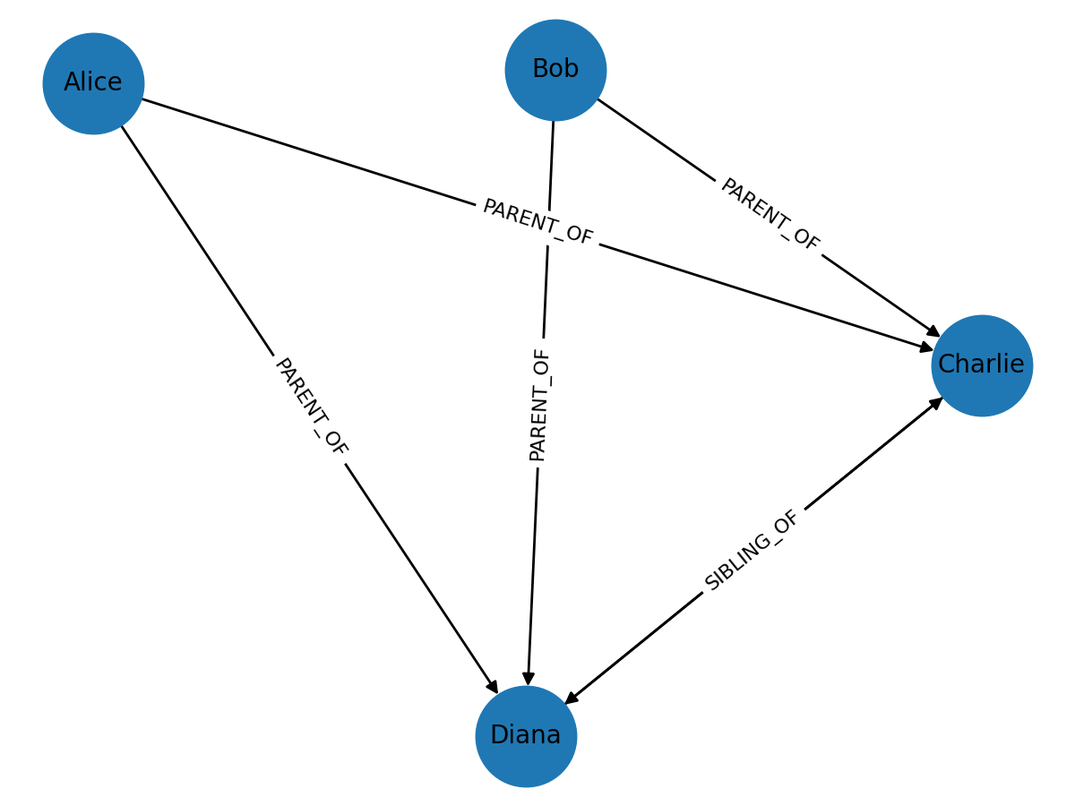
Figure 1. Family Relationship Graph Model

Nodes (Alice, Bob, Charlie, Diana) are connected by PARENT_OF and SIBLING_OF relationships. Directed arrows encode traversaldirection; for siblings we use a pair of opposite edges to represent symmetry.

Diagram Interpretation:
- There are four Person nodes: Alice, Bob, Charlie, and Diana.
- Parent-child relationships: Alice is a parent of Charlie, Bob is also a parent of Charlie, Alice is a parent of Diana, and Bob is a parent of Diana.All these relationships are of the type PARENT_OF.
- Siblings: Charlie and Diana are siblings, connected through two directed SIBLINGS_OF relationships.
- Meaning: The PARENT_OF relationship shows a parent-child link, and by following these links, you can trace family connections across generations.
Example Queries:
- To find the children of a person:
Match a Person node named Alice and find all Person nodes connected through a PARENT_OF relationship like:

MATCH (p:Person {name:'Alice'})-[:PARENT_OF]->(c:Person) RETURN c
- To find the siblings of a person:
Match a Person node named Charlie and find all Person nodes connected through a SIBLING_OF relationship like:

MATCH (x:Person {name:'Charlie'})-[:SIBLING_OF]->(sib:Person) RETURN sib
- To find all parents of a person:
Match all Person nodes that have a PARENT_OF relationship leading to a Person node named Diana like:

MATCH (par:Person)-[:PARENT_OF]->(:Person {name:'Diana'}) RETURN DISTINCT par

Part 6: Demo
We’ll now show you how to set up Neo4j using Docker and run a simple family graph example that's easy for beginners. The screenshots provided are simulated and are meant to help you understand the steps if you don't have a local Docker environment available.

Step 1: Run Neo4j in Docker
Open a command terminal and run this code:
“docker run -d --name neo4j-family -p7474:7474 -p7687:7687 \
-e NEO4J_AUTH=neo4j/password neo4j:latest”
Tip: If ports are in use, stop previous containers (docker stop <name>) or change host ports.
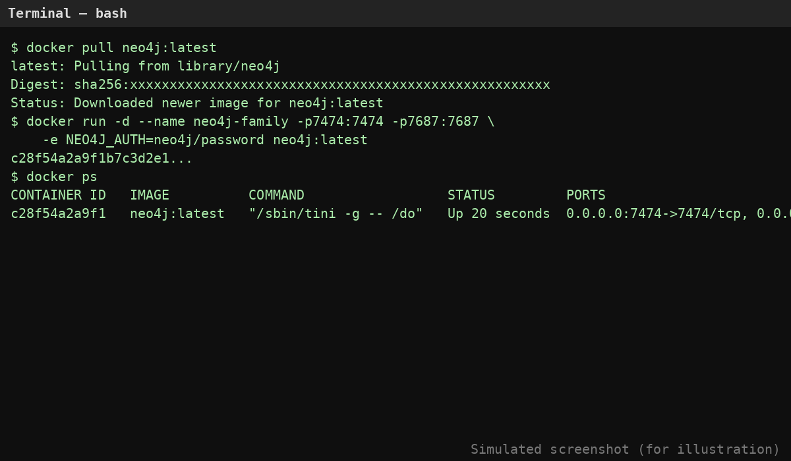
Screenshot 1. Terminal showing docker pull/run and docker ps output

Step 2: Open Neo4j in Your Browser
Navigate to http://localhost:7474 and sign in with user neo4j and the password you set above. If prompted, you can change the password on first login.

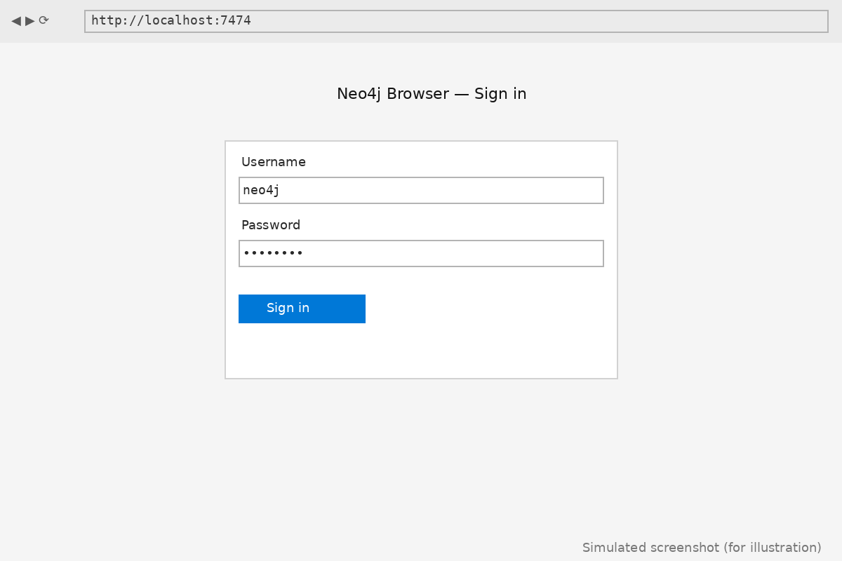
Screenshot 2. Neo4j Browser login page

Step 3: Create the Family Graph
Run the following Cyphers in the query editor to create nodes and relationships:

- CREATE (a:Person {name:'Alice', birthYear:1970});
- CREATE (b:Person {name:'Bob', birthYear:1972});
- CREATE (c:Person {name:'Charlie', birthYear:1995});
- CREATE (d:Person {name:'Diana', birthYear:1998});
- MATCH (a:Person {name:'Alice'}), (c:Person {name:'Charlie'}) CREATE (a)-[:PARENT_OF]->(c);
- MATCH (b:Person {name:'Bob'}), (c:Person {name:'Charlie'}) CREATE (b)-[:PARENT_OF]->(c);
- MATCH (a:Person {name:'Alice'}), (d:Person {name:'Diana'}) CREATE (a)-[:PARENT_OF]->(d);
- MATCH (b:Person {name:'Bob'}), (d:Person {name:'Diana'}) CREATE (b)-[:PARENT_OF]->(d);
- MATCH (c:Person {name:'Charlie'}), (d:Person {name:'Diana'}) CREATE (c)-[:SIBLING_OF]->(d);
- MATCH (d:Person {name:'Diana'}), (c:Person {name:'Charlie'}) CREATE (d)-[:SIBLING_OF]->(c);

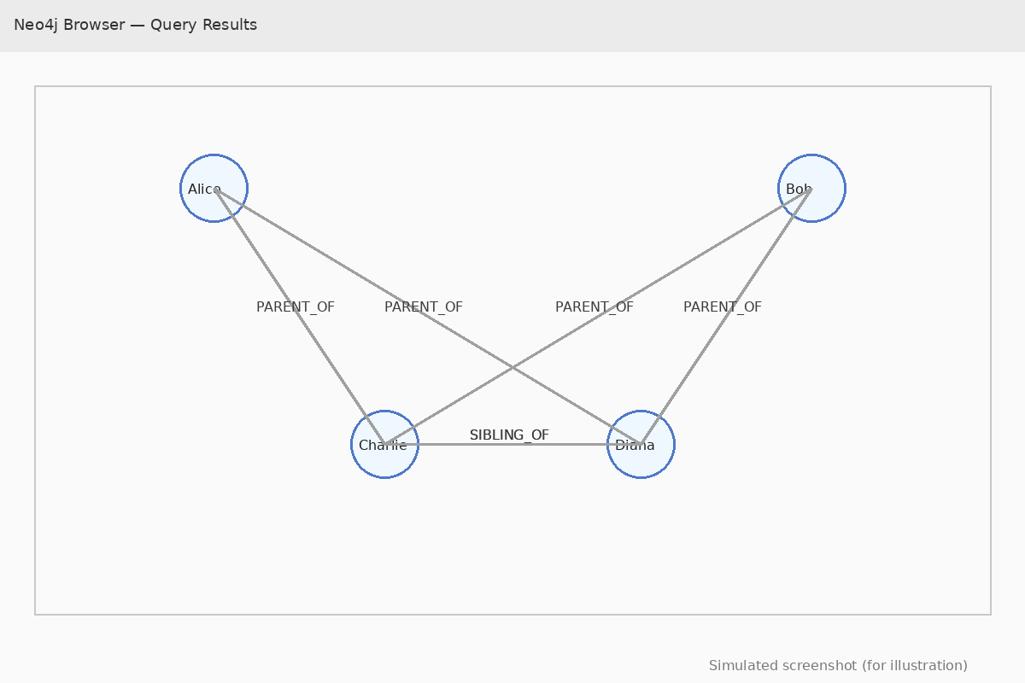
Screenshot 3. Graph visualization after creation

Step 4: Query the Graph
Example queries:
- List Parents and Children
MATCH (p:Person)-[:PARENT_OF]->(c:Person) RETURN p.name AS Parent, c.name AS Child;
- Find Siblings of Charlie
MATCH (:Person {name:'Charlie'})-[:SIBLING_OF]->(sib) RETURN sib.name;
- Count Children Per Parent
MATCH (p:Person)-[:PARENT_OF]->(c:Person) RETURN p.name, count(c) AS children;

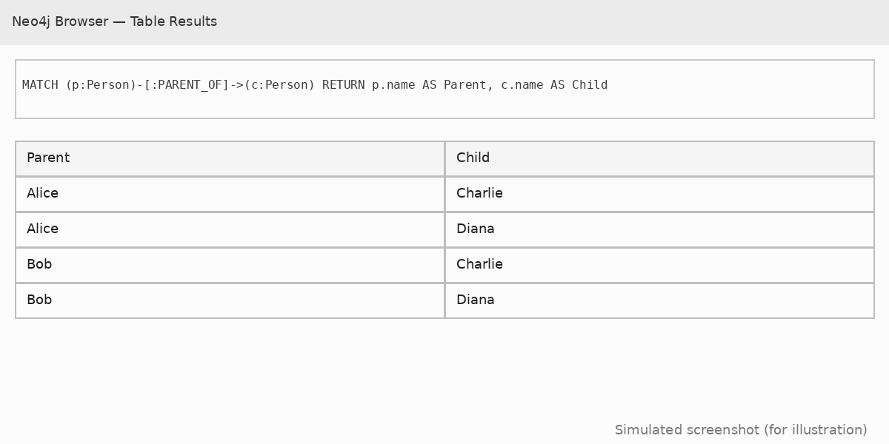
Screenshot 4. Table results for parent–child query
Part 7: Real-World Impact
This is how Neo4j helps in the real world (in simple terms):

- Catching Bad Guys Who Cheat
Imagine you’re playing a game and someone is cheating. Neo4j is like a super detective that connects all the clues together—who played, what they did, and when they did it—so it can spot the cheater quickly.

- Giving Better Suggestions
Have you ever watched a video online and then it showed you another one you might like? Neo4j can help apps figure that out. It looks at what you like and finds other things similar to it so you get fun ideas faster.

- Making Smart Maps for Computers
Neo4j can make “maps” of how things are related—like which animals eat which foods, or how different countries are connected. Computers can then use these maps to answer questions and learn new things.

- Keeping Information in One Place
Imagine your school had some of your grades in one notebook, your attendance in another, and your lunch menu in another. Neo4j can bring it all together so your teacher can see everything in one place.

- Finding the Best Paths
If you were delivering pizza to a bunch of houses, Neo4j could help you figure out the fastest way to visit all the houses without wasting time.
- Watching Who Has the Keys
Neo4j can keep track of who has permission to go into certain “rooms” in a computer system. That way, it’s easy to see who can open which doors and make sure no one goes where they shouldn’t.

Part 8: Group Activity and Contribution
Isaac Adebayo contributed to this tutorial by completing sections 3 & 4.
Farhana Manzoor contributed to this tutorial by completing sections 5 & 6.
Michella Maddox-McGhee contributed to this tutorial by completing sections 1, 2, 7, 8 & 9.

Part 9: Conclusion
We have now reached the very last part of our lesson about Neo4j. You have learned what Neo4j is and how it is different from other ways of storing information. Instead of stacking facts in straight rows like a chart, it connects them like a giant web where every dot and line has a meaning. We talked about how it can grow bigger and bigger without slowing down, which is called scalability, and how it can still find answers very quickly even with a huge amount of information, which is called efficiency.

You also learned how to set up Neo4j, how to ask it questions using its special language called Cypher, and how to arrange your information so it is easy to explore. We looked at how it can be used in real life, such as catching someone who is cheating, giving ideas for videos or games you might like, making smart maps that computers can use, or helping a big company keep all its information in one place.

We practiced working with nodes, which are like the dots that hold your pieces of information, and relationships, which are the lines that connect those dots together. You also learned about variables in the code, which are like labels or names you give to nodes or relationships so you can use them later in your query. These parts work together in Cypher code to help Neo4j understand exactly what you are looking for and how to find it.

This is the end of our journey together. You now know how Neo4j works, why it is so good at connecting information, and how it can help solve all kinds of problems. Whether you use it for your school projects, games, or just for learning on your own, you can now see how a smart database like Neo4j can turn a big tangle of facts into a clear story. The rest is up to you to explore, create, and discover.

